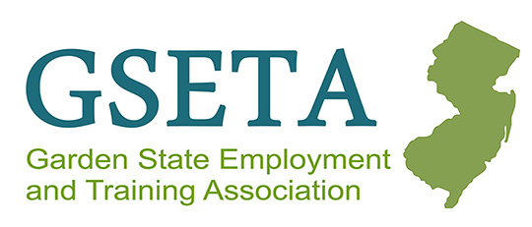

GSETA Fiscal Committee Meeting
Virtual via Microsoft TEAMs
Tuesday, August 13, 2024, at 9:00 AM

Meeting Summary Minutes

The meeting was scheduled to review the NJWIN WD-PY24-2: https://www.nj.gov/labor/assets/PDFs/WIOA/documents/resources/WD-PY24-2%20WIOA%20and%20WFNJ%20Budget%20Guidance%20(Final).pdf

Direct Service 40% Allocation
- The 40% allocation goal for direct services is based on benchmarks observed by NJDOL in other states, though the current allocation is lower than some others. This goal serves as a guideline to encourage increasing the percentage of funds allocated to direct services rather than a strict requirement. NJDOL is working to improve tracking systems on the state side to better understand actual direct service levels. Initial steps include setting a benchmark and enhancing data tracking. NJDOL aims to collaborate with stakeholders to maximize the amount of funding directed toward direct services.
- The aim is to spend as much money as possible on training. NJDOL wants to make it clear that this benchmark is a goal rather than a requirement. Discussions and further dialogue will occur before any requirements are established. There may be a need for adjustments in IGX, particularly on the WFNJ side, to improve tracking.

Professional Development
- NJDOL will not be organizing professional development with GSETA as we did last year due to procurement issues. Local areas have the flexibility to decide how to manage their professional development funds. The decision is up to the local areas.
- There is no minimum requirement, but it is recommended to include a budget line item for professional development. NJDOL encourages maintaining a sustained professional development strategy.

Expenditure Procedures
- All changes to budget line items require notification with an explanation sent to the WIOA POD email.
  - For WFNJ budget line items, it is currently unclear who should receive these notifications. Kendra Lee will connect with the WFNJ team to determine whether notifications should go to WIOA POD or another email address.
- Changes of 10% or greater require approval.
- The 10% rule applies to the combined budget for multi-county areas.
- The current policy requires approval for any 10% or greater change within a month. NJDOL will discuss how to handle cumulative budget changes that reach 10% over time. But at this time, they have not discussed it, and the current policy stands.

Drawdowns
- For any issues or delays, contact Sally and Nalini at the Accounting and Fiscal departments, as they are the local area contacts as outlined on page 7 of the Fiscal Policy.
  - Sally Pezzino - sally.pezzino@dol.nj.gov
  - Nalini Ammanamanchi - nalini.ammanamanchi@dol.nj.gov

Cost Allocation Plans (CAP)
- It has been clarified those changes to cost allocation plans do not generally require notification unless they result in a 10 percent change to a budget line item. Then you would follow the Expenditure Process. However, quarterly time studies for labor distribution, or similar methods used to create your CAP do not necessitate notification.

Next Meeting:

September 24th at 9:00 AM

